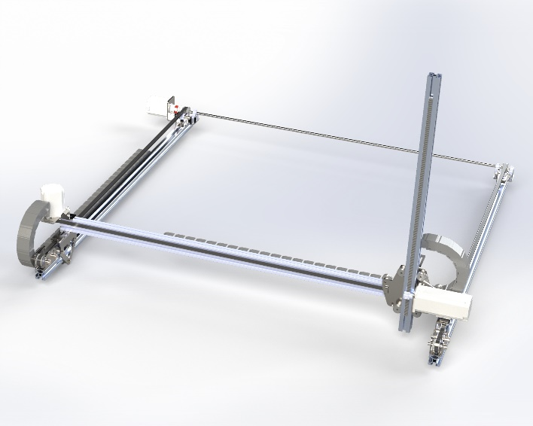
Drive system x axis:
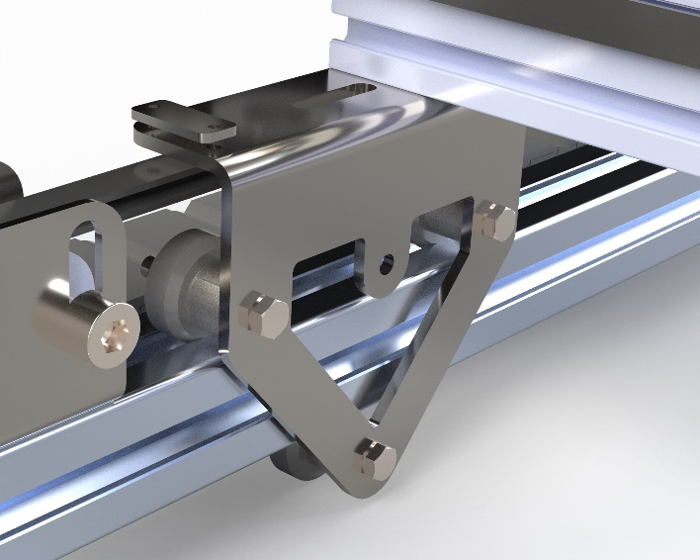
On the x-axis the two trolleys which are each connected to the 20x40 mm profile run over two 30x30 mm profiles. The trolleys are driven by a closed loop stepper motor which distributes the power evenly to the second trolley through a drive shaft. We use an AT5 belt and a wheel with 16 teeth. With this combination and the Nema 23 which has a relatively high torque at 250 rps we get a linear speed of 333mm/s on the x axis. The first energy chain also runs along the side of the motor and is connected to the trolley to guide the cables. In addition, a micro switch is mounted at the beginning of a profile to determine the zero point for machine control.
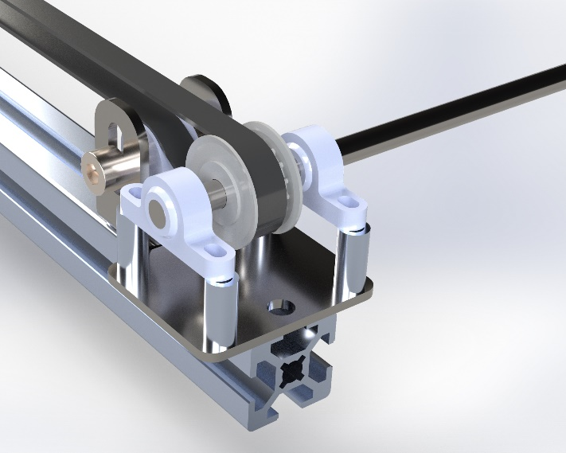
The trolleys are made of 3 mm stainless steel and bent to a right angle. Therefore the profile rests on the upper side and the rollers are attached to the side with a bolt and spacer. The bolt of the lower roller is in a slot to vary the tension on the profile and to guarantee a stable connection between trolley and profile. There are two holes on each side of the trolley to connect the belt to the trolley with another piece of sheet metal.
As on all three axes, we use the nema 23 closed loop stepper motor with 2.3Nm holding torque, which has a high starting torque and therefore fits perfectly for our gantry system to still move it at the desired speed. On the x-axle the motor is attached to a sheet metal part and after a clutch it transmits the power to an axle which drives both belts on the x-axle. The pulleys are attached to the axle with a lockring. In addition, there are belt tensioners on both sides which guide the belt through the trolley and thus take up less space and also offer the possibility of tensioning the belt.

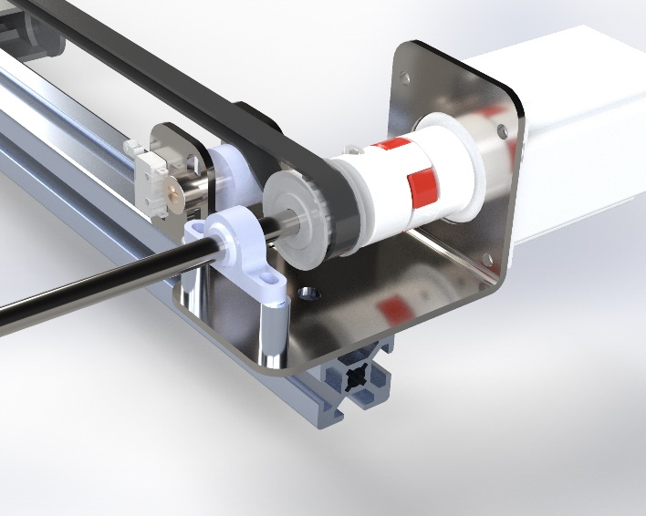
Drive system y axis:
On the y-axis we have a similar drive system with the same motor pulley and belt which results in the same working speed. The trolley on the y axle serves as a support for the drive system on the z axle. The trolley runs over the aforementioned 20x40 mm profile. Opposite the trolley, the energy chain runs along to guide all the cables. A micro switch is also mounted on this axle.
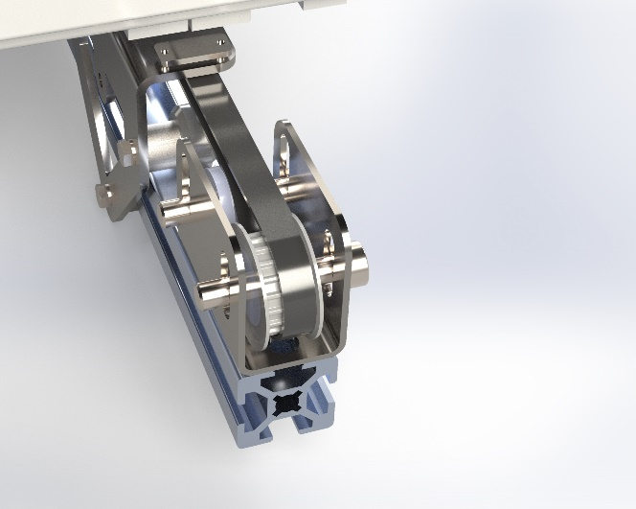
The trolley is made of laser-cut stainless steel with wheels on both sides to guide the aluminum profiles. There are also belt clamps for the y-axis on both ends of the trolley to ensure a connection to the drive system.
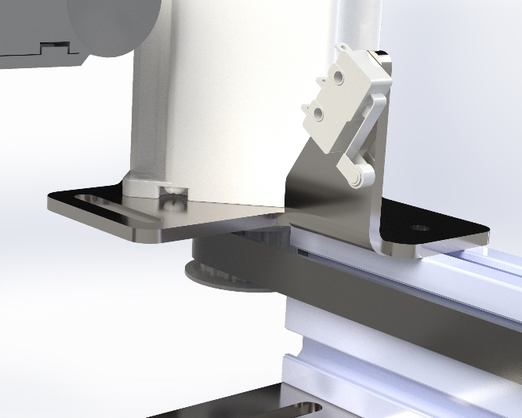
Due to the Z-axis, relatively high horizontal moments act on the trolley and also on the leading profile. The 20x40 mm profile is therefore a good compromise to absorb the forces and at the same time ensure a good weight ratio. The narrow design of the profile allows the belt to be guided along the outside and saves space.

Drive system z axis:
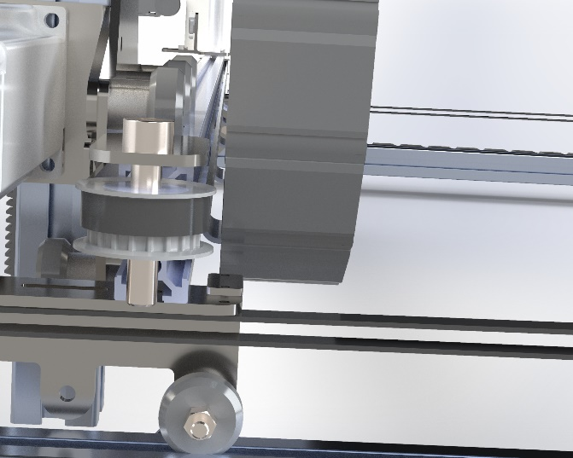
We use the same motor on the z axle, except that it also has a brake with a braking force of 2 Nm, to counteract the force of gravity. A gear rack is embedded in the 30x 30mm profile, which results in a vertical movement through the gear wheel on the shaft of the motor. In contrast to the x and y axes, it is not a trolley that moves back and forth, but the entire profile, as we need the space under the portal system. As a result, it is not possible to mount the profile or another guide rigidly and let a trolley run along it to reduce the mass inertia.
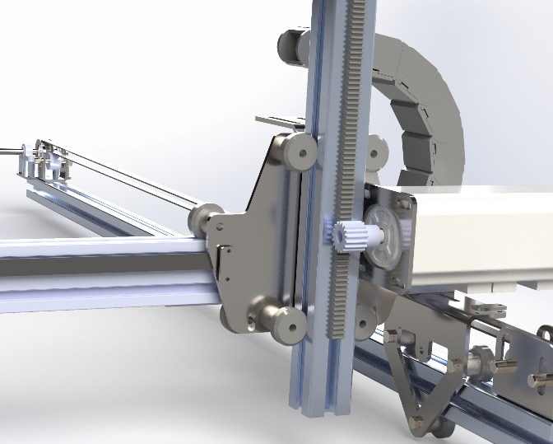
On the side of the trolley where the z-axle profile runs, there is another 2 mm stainless steel motor bracket, which ensures easy mounting of the motor. The connection points are slots to perfectly adjust the distance between the pinion and the rack. As already mentioned, the rack is embedded in the profile and is fastened with a scraper system. It consists of a thermoplastic material polyacetal, which has several advantages. High hardness, low weight and a low coefficient of friction contribute to the fact that racks made of Hostaform C exhibit more favorable abrasion behavior than racks made of other plastics - and even some metals. This enables oil-free operation, which does not attract dirt and therefore supports durability.

Conclusion
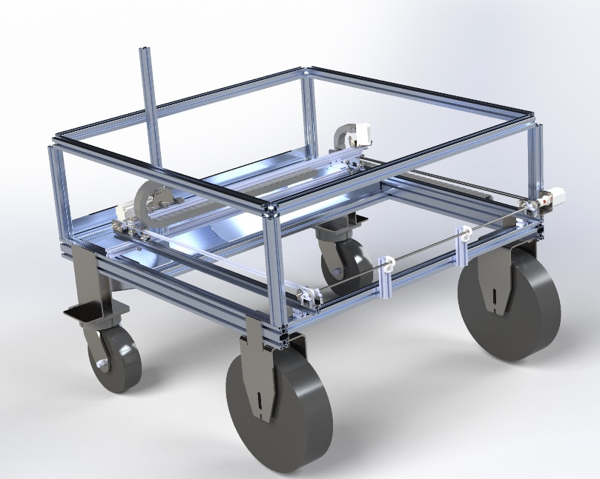
The drive system for the x, y, and z axes has been carefully designed to ensure high precision, stability, and efficiency in our gantry system. By utilizing Nema 23 closed-loop stepper motors with high torque, we achieve reliable motion across all axes while maintaining the desired speed. The integration of AT5 belts, pulleys, and a drive shaft allows for even power distribution, reducing mechanical stress and ensuring smooth operation.
For the x and y axes, the use of stainless steel trolleys, belt tensioners, and energy chains optimizes space while providing a stable and adjustable connection to the profiles. The micro switches on both axes contribute to accurate machine control by defining zero points.
On the z-axis, the implementation of a gear rack and pinion system, combined with a motor brake, effectively counteracts gravity and enhances vertical stability. The choice of polyacetal for the rack ensures low friction, durability, and maintenance-free operation, contributing to overall system longevity.
Through this well-engineered drive system, we achieve a balance between strength, precision, and efficiency, making the gantry system suitable for demanding applications.

